HAVE YOU CHECKED LATELY?
Make sure their littleSTEPS® Orthotics or littleSTEPS® Gait Plates are the right size. They play an important role in Balance, Gait, Posture, and Comfort. Here’s a quick way to see if it’s time for the next size:

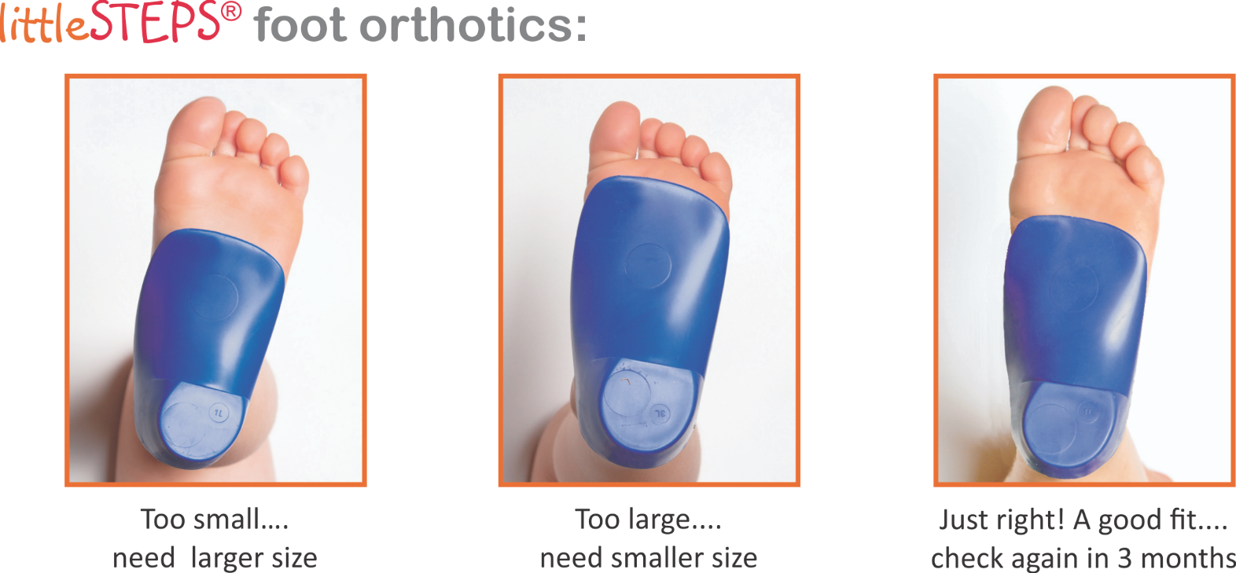

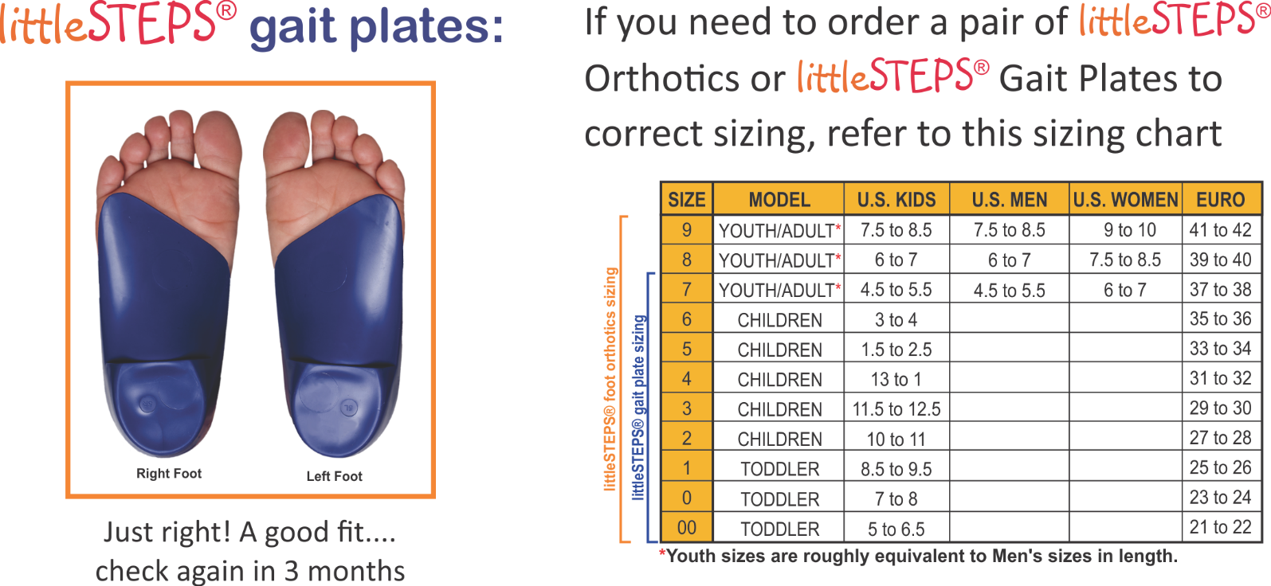

Make an appointment now to get the right size littleSTEPS® Orthotics or littleSTEPS® Gait Plates
Come in by (date) and get a 10% discount off the next size. Make sure your kids are wearing the right size!

BUSINESS NAME/LOGO, ADDRESS, WEBSITE
CALL (PHONE NUMBER)

